
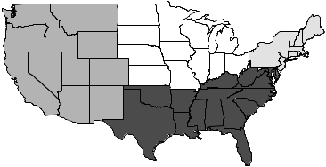
INFOSHARE ONLINE

Subscription Form

Community Information Service InfInformation Service

Date ___/___/___
Organization: _________________________________________________________________
Account ID (20 characters or less): ________________
IP addresses _____________________________________________________________
or
User Password (20 characters or less): ________________

Account Administrator: ____________________________ Title: ________________________
Phone: ____________________________ Fax: ____________________________
E-Mail____________________________________

Annual Subscription Fees:
Organizations:
Up to 5 users - $300
Up to 10 users - $500
Unlimited via IP address: Organizational Budget Fee
Less than $250,000 $100
$250,000-$2,000,000 $250
$2,00,000-$10,000,000 $500
Above $10,000,000 $1,000

Please fax this completed form to 212-580-1247, or mail to:
Community Studies of New York, Inc.
155 W. 72nd Street Suite 402
New York, NY 10023

If you prefer, you can e-mail this information to: email@infoshare.org.

If you have questions, contact Leonard Rodberg, 212-580-3890.

